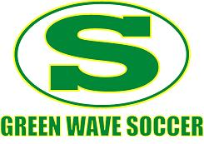
Summerville High School
2023 Boys Soccer Team
Name Number Year Position
Connor Tuttle © 7 12 Defense
Jacob Russ © 21 12 Midfield
Aidan Jackson © 12 12 Midfield
Eli Savage 6 12 Defense
Riley Caughell 3 12 Wing
Cooper Riley 4 12 Wing
Jayvyn Wynter 16 12 Offense
Tommy Jenkins 00 12 Keeper
Mason Ayers 14 12 Defense
Stephon Hudson 11 12 Wing
Collin Dahlman 01 11 Keeper
Patrick Cox 8 11 CB
Gunnar McNeish 10 11 Striker
Nollan Riley 9 11 Wing
Preston Smith 13 11 Striker
Luca Duckworth 16 11 Striker
Eric Leon 5 11 Defense
Paxton Elrod 20 10 CB
Bennett Kelley 2 10 Defense
Carter Wells 18 10 Striker
Sam Willeford 17 10 Defense
River Orbin 9 9 Defense
Rhys Jones 7 9 Midfield
Landen Malone 5 9 Midfield
Christopher Marshall 99 9 Keeper

Head Coach: Damon Dixon (864) 483-8776
Assistant Coaches: Stephen DiPaulo (JV Head Coach)
Derek Ayers
Fab Jean-Gilles
Manager: Andrew Beason (student)

